Bacani, Micah Angelo R. 2018 – 01602

Activity 6

1. 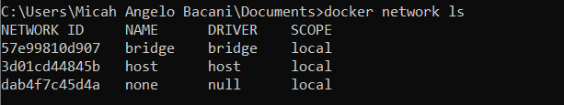Listing networks
2. 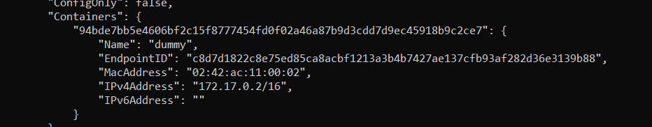Inspect bridge with container already
3. 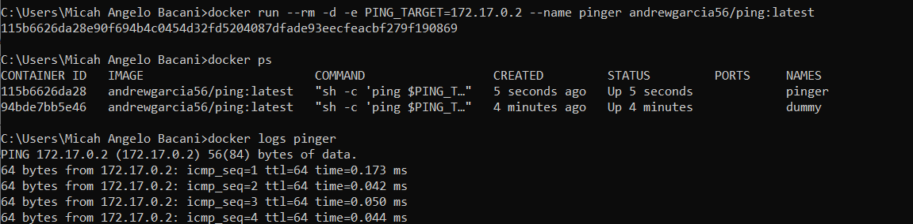Creating a pinger container
4. 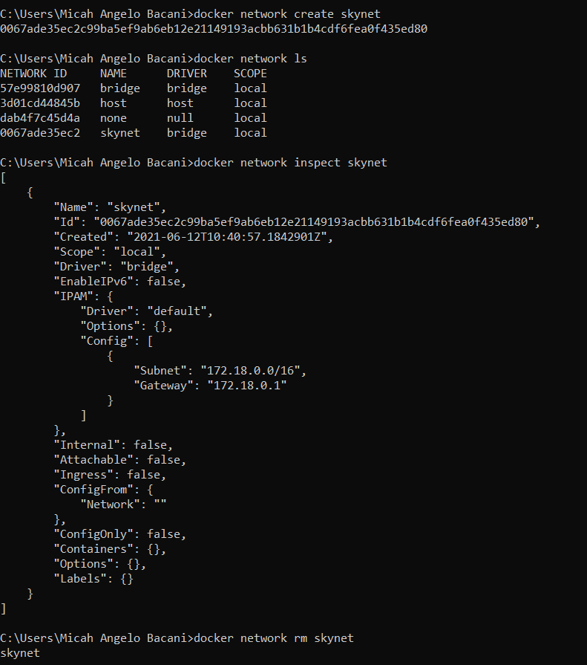Creating and removing network



1. 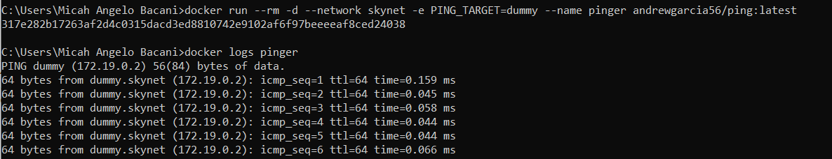Adding containers in the same network
2. 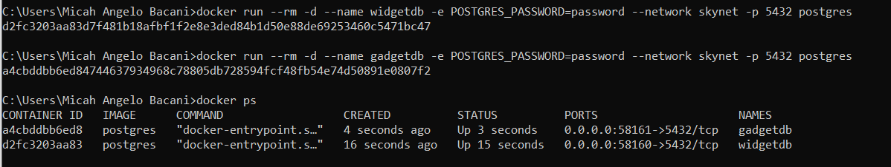Starting each database
3. 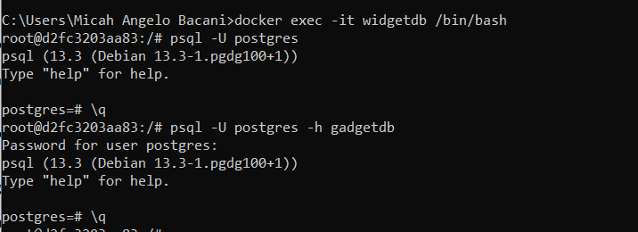Connecting to local database
4. Running psql on on local machine
   1. Was not able to do this because I do not have psql on my machine